The Department of Classical Studies Will Host the Workshop

Ethnicity and Ethnic Constructs
in the Long History
of the Ancient Mediterranean and Black Sea

University of Waterloo, German Reading Room (ML 245)
Wed.-Th., April 26-27, 2023

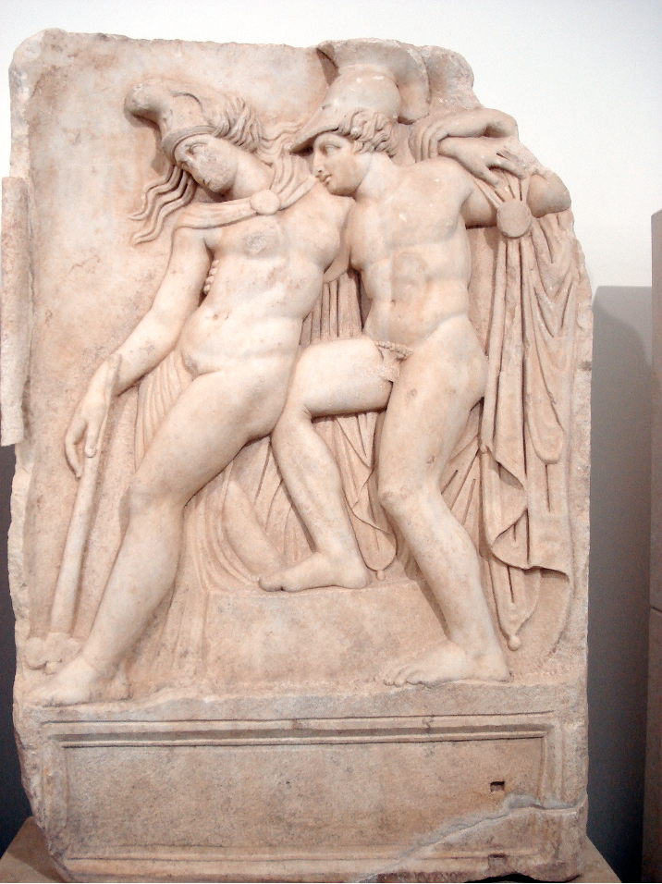

Rather than a static or natural form of belonging, ethnicity is an ongoing site of social production and negotiation. It can be both the source and the product of identity. Our workshop will explore how ancient societies defined, constructed, and leveraged ethnic belonging. How did (or does) ethnicity work alongside other social categories, political exigencies, and cultural imaginations? What is changing about our traditional historical questions, if anything, when ethnicity is foregrounded in the analysis? Case studies will range from Archaic Greek colonization over Herodotus’ representation of the Persians, representations of wise men and pirates, Hellenistic Judaism, the iconography of others in Roman Egypt, and Christian concepts of identity in the Later Roman Empire.
For abstracts and further information, see http://www.altaycoskun.com/ethnicity-workshop-2023
All are welcome. If you wish to attend, please, contact acoskun@uwaterloo.ca or maiakotrosits@gmail.com.

