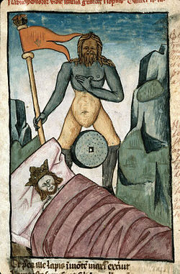
Succession of Ancient Empires
A Workshop Hosted at the Department of Classical Studies at the University of Waterloo
German Reading Room (ML 245)
Fr., Feb. 28, 2020

Program
9:30-10:00 Tea / Coffee, Welcome and Introduction
Panel I: The Transition of Eras and Dynasties: Material Evidence and Ideological Perspectives
Chaired by Andrew Sherwood, University of Guelph
10:00-10:50 Dr. Agnieszka Wojciechowska, University of Wroclaw, Poland:
Succession of Empires in Egypt from the 30th Dynasty to Ptolemy I
11:00-11:50 Dr. Mac Lewis, University of Waterloo ON:
The Sullan Foundation of Roman Florentia
12:00-12:50 Dr. Krzysztof Nawotka, University of Wroclaw, Poland:
The Epigraphic Habit in Western Asia Minor and the Transition of Empires
13:00-14:00 Lunch Break
Panel II: Imperial Allegories in Daniel
Chaired by Phil Harland, York University, Toronto
14:00-14:50 Dr. Altay Coşkun, University of Waterloo ON:
A Giant and Some Beasts in Daniel’s Prophecies – Allegories that Want to Be Decoded
15:00-15:50 Dr. Ben Scolnic, Temple Beth Sholom, Hamden CT & Southern CT State University:
The Unfulfilled Vision: Dan 11:14 and the Rebellion in Jerusalem during the Fifth Seleukid-Ptolemaic War
15:50-16:15 Tea / Coffee Break
Panel III: Conceptualizing Empire, Succession and Continuity
Chaired by Krzysztof Nawotka, University of Wroclaw, Poland
16:15-17: 00 Stone Chen, University of Waterloo ON:
Tianxia and Oikoumene: Two Conceptions of Empire
17:00-17:50 Dr. Richard Wenghofer, Nipissing University, North Bay ON:
Empire and Culture: Decolonizing the Evidence for the Indo-Greek Kingdoms
17:50-18:00 Concluding Remarks
Everyone is welcome, but registration is required. Please, contact acoskun@uwaterloo.ca

